Creating Instance

1. Choose OS Ubuntu 16.04
2. Set disk 50 GB
3. Choose GPU card if you need the GPU
4. Choose specification of CPU and RAM that you need

Install Cuda and Cudnn

1. Choose Cuda version 9.2 <https://developer.nvidia.com/cuda-92-download-archive?target_os=Linux&target_arch=x86_64&target_distro=Ubuntu&target_version=1604&target_type=debnetwork>

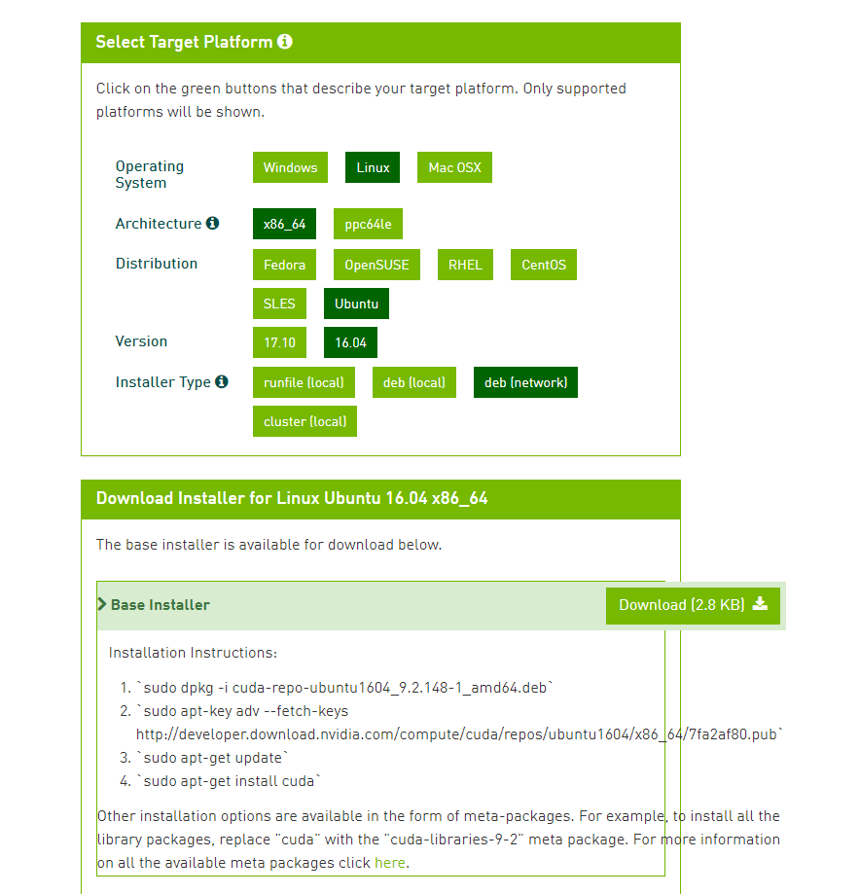

Download deb file, then transfer to instance gcp using gcloud sdk.



1. Remote the instance , install the cuda

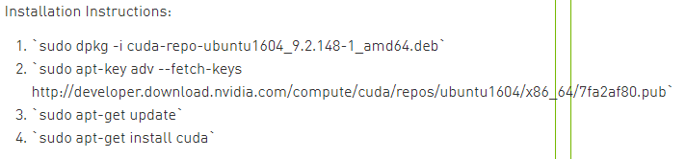

1. Download cudnn for cuda version 9.2 is 7.1.4 and transfer to instance using gcloud sdk

<https://developer.nvidia.com/rdp/cudnn-archive>

1. Copy cudnn to folder cuda

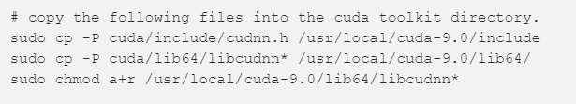

1. Install pip3 for python3



1. Install all libraries that you need for your model

Configuration nginx

1. Go to /etc/nginx/ directory
2. Edit nginx.conf file like nginx.conf from this repos <https://github.com/gideonmanurung/Setup_GCP_Instance_EndtoEnd\>

Configuration for add script api as service on linux

1. Go to /etc/system/system. Directory
2. Create new .service file for your project like service file from this repos

<https://github.com/gideonmanurung/Setup_GCP_Instance_EndtoEnd>

1. For next step , load .service file as service on os linux.
2. Start the service
3. Control the service
4. Details information from https://tecadmin.net/setup-autorun-python-script-using-systemd/